Everyone that authors an R package is curious about **how many users** download it. As far as I know there’s still no way to get information on *all* the downloads, from *all* the R mirrors. Here I’m using package **cranlogs**, which only gives information on the downloads from the **R Studio mirror**. It also does not allow to now from where in the world these downloads were made. However, it has a major advantage: speed! The package **cranlogs** provides a easy (and *way* faster) method to get this information **without having to download all the log files** (which can take a long time).

I have written **this little script**, which I use to keep track of my packages’ downloads (here I’m using MetaLandSim as an example).

First of all let’s **load all the required R packages**:

#install.packages("cranlogs")

library(cranlogs)

library(ggplot2)

If we want to know about **last week’s** downloads:

#Last week's downloads

cran_downloads(packages="MetaLandSim", when="last-week")

## date count package

## 1 2019-03-30 7 MetaLandSim

## 2 2019-03-31 7 MetaLandSim

## 3 2019-04-01 11 MetaLandSim

## 4 2019-04-02 30 MetaLandSim

## 5 2019-04-03 30 MetaLandSim

## 6 2019-04-04 19 MetaLandSim

## 7 2019-04-05 11 MetaLandSim

Or about the **overall downloads** (the last date has to be the previous day):

#How many overall downloads

mls <- cran_downloads(packages="MetaLandSim", from = "2014-11-09", to = Sys.Date()-1)

sum(mls[,2])

So… the **number of downloads** MetaLandSim has is…

## [1] 21868

We can now **plot** the resulting graph, depicting the **daily downloads**:

#Plot

gr0 <- ggplot(mls2, aes(mls2$date, mls2$count)) +

geom_line(colour = "red",size=1)

gr0 + xlab("Time") + ylab("Nr. of downloads") +

labs(title = paste0("MetaLandSim daily downloads ", Sys.Date()-1))

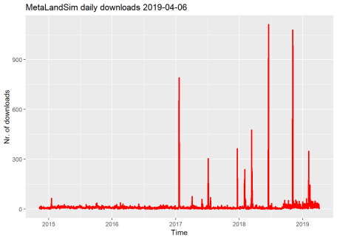

Or we can plot the **cumulative downloads sum** to get an idea about the **rate of increase in download numbers**:

#Cumulative

cumulative <- cumsum(mls[,2])

mls2 <- cbind(mls,cumulative)

#Plot

gr1 <- ggplot(mls2, aes(mls2$date, mls2$cumulative)) +

geom_line(colour = "blue",size=1)

gr1 + xlab("Time") + ylab("Nr. of downloads") +

labs(title = paste0("MetaLandSim cumulative downloads until ", Sys.Date()-1))

